Introduction
I_{b} = design current
I_{n} = Protective/fuse rating breaker size
I_{z} = Cable rating

NOTE: I stands for current. I_{b} I_{n} and I_{z} are all current based.

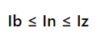

Simple example:
- Heater has a design current of 5
- needs to have a fuse of 6
- and a cable rating of 7.2.

Tutor aside: Always have leeway when it comes to I_{b}, I_{n} and I_{z}. For example, it says “less than or equal to”. make sure it is always greater than. As shown in this example.
I_{b​} – Design current: The actual current that the load is expected to draw under normal operation.
I_{n}​ – Nominal current: of the protective device: The rated current of the circuit breaker or fuse (e.g., a 16 A MCB).
I_{z}​ – Current-carrying capacity:(ampacity) of the cable or conductor, under the given installation conditions.

START FIRST PRACTISE

Question:

If we run a cable in a 30 degree room.
With a Twin and Earth 70 degrees.
Grouped with 7 cables with 320mm insulation
And a 32 A breaker.

Workings out:

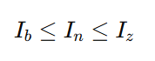
I_{b} = design current
I_{n} = Protective/fuse rating breaker size
I_{z} = Cable rating

The first step is to calculate the design current => I_{b}.
I_{b} = ??

The second step is to calculate the breaker size => I_{n}
I_{n} = 32 A breaker.

The third step is to calculate I_{z} => cable rating;
- The pre-requisite is to calculate I_{t} => current carrying capacity.

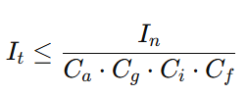
- The base formula to deduce I_{t} => current carrying capacity.

C_{a} => ambient temperature
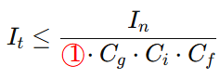
- C_{a} - The ambient temperature is deduced as 1 from Table F1 on page 168.

C_{g} => grouping
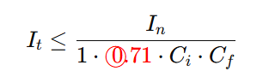
- C_{g} - is deduced as 0.71. Because there are seven cables in the wall. So this additional cable makes 8.

C_{i} => thermal insulation
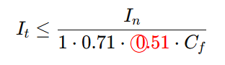
- C_{i} - is deduced as 0.51. Because the question states “320mm insulation” which, when rounded up to 400. Corresponds to 0.51 Derating factor (C_{i} ).

C_{f} => account for 3036 fuse box
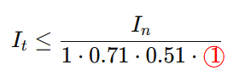
- C_{f} - is deduced as 1. As the on guide site states “for all other devices C_{f} = 1. ”

I_{n} => represents the current at which the protective device is designed to operate in order to protect the circuit from damage.
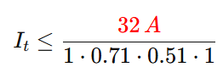
- I_{n} - The question gives us the breaker size as 32 A

Therefore I_{t} ,

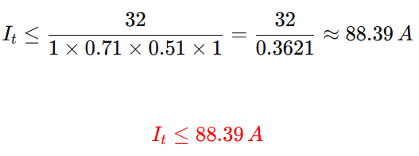

END FIRST PRACTISE

START SECOND PRACTISE
Question:

I_{n} is 45. The total answer is 63.

A shower is running through 100mm insulation. Which has a 70 degree thermoplastic cover. The cable is fitted into an enclosed wall with 6 circuits. The shower requires 7.2 kW to run and uses 230 volts.
The temperature of the bathroom is 25 degrees.
Finally, Sam’s fuse box has not been updated in a while and is version 3036.

Workings out:


- I_{b} = design current
- I_{n} = Breaker Size
- I_{z} = cable rating

The first step is to calculate the design current => I_{b}.

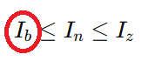
- To calculate the design current (I_{b}) we use the PIV formula triangle;
- The answer for I_{b} will be measured in amps.

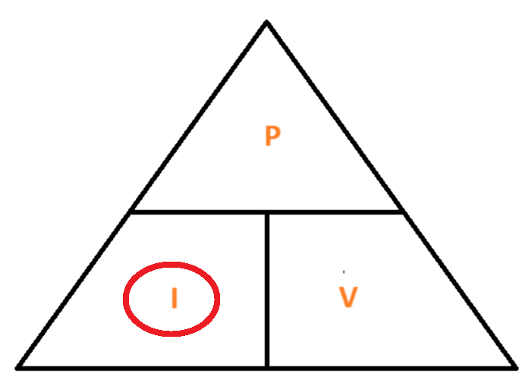 PIV formula triangle
- I = P / V or
- Current = Power / Voltage;
- 7.2 kW / 230 volts = 31.30 amps.
- 7,200 / 230 = 31.30 A

Diversity rule check

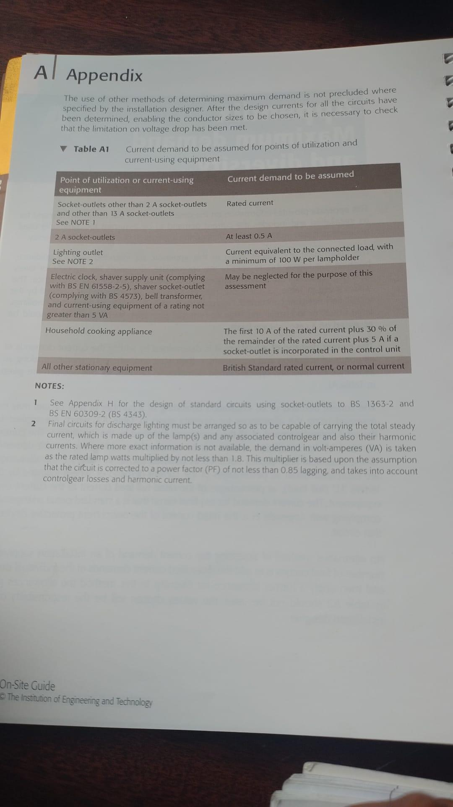

- For I_{b} (the design current) check if the appliance appears on table A1 on page 136;
- If yes, apply the diversity calculation;
- In this instance a shower does not appear on the table;
- So I_{b} = 31.30 amps.

The second step is to calculate the breaker size => I_{n}

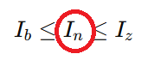
- To calculate I_{n} read the Header row on Table B1 (page 140);
- We must calculate the right sized breaker to use;
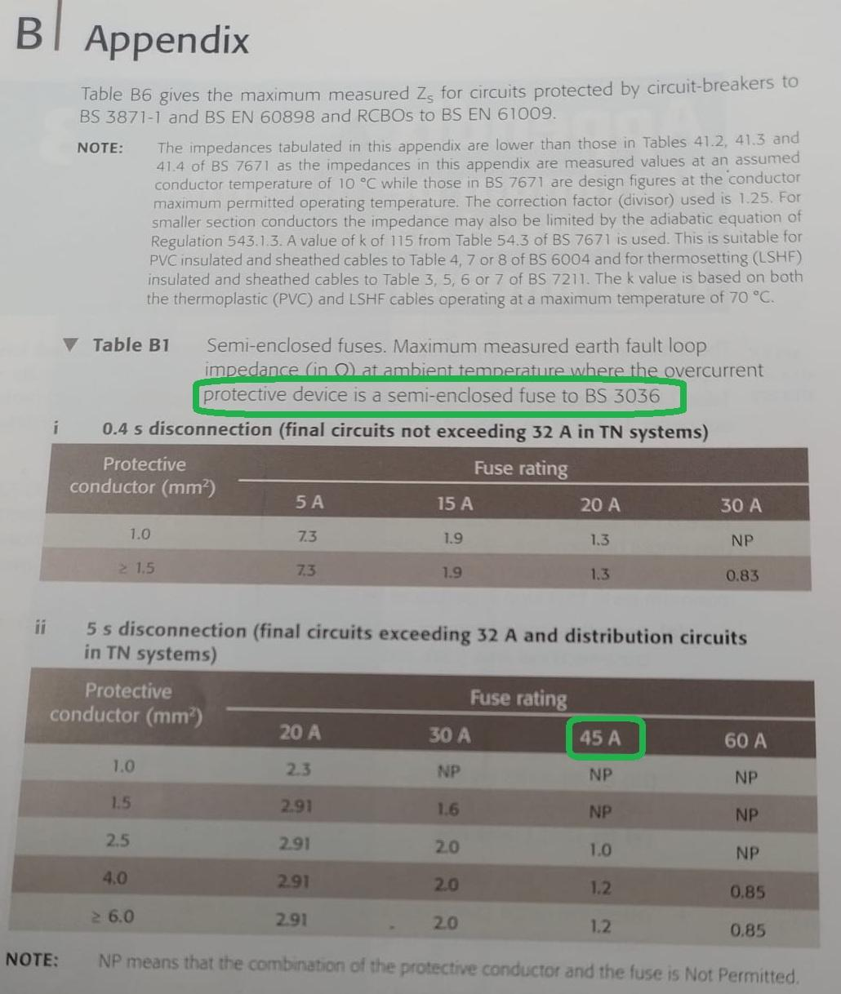
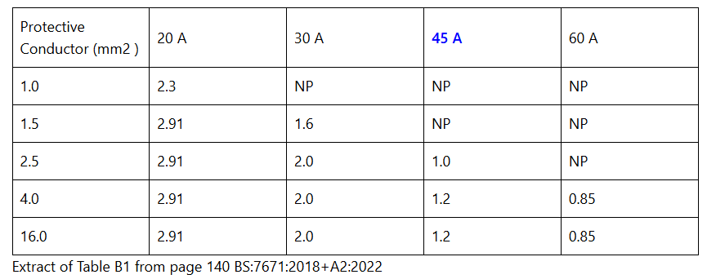
- The design current (I_{b}) has been calculated as 31.30 amps - as deduced in the first step;
- Round up to the nearest value in the header row table Table B1 (page 140);
- From the table we can conclude that the right breaker size is 45 A for a design current (I_{b}) of 31.30 amps;
- 30 A and 20 A are too small. 60 A is too large
- Note that we highlighted “protective device is a semi-enclosed fuse to BS 3036”

The third step is to calculate I_{z} => cable rating;

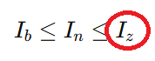
- To calculate I_{z} => cable rating;
- We must first calculate I_{t} => current carrying capacity .

I_{t} => current carrying capacity formula
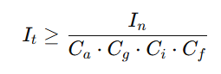
- The above formula is used to calculate I_{t};
- From I_{t} we can deduce the value of I_{z};
- Use page 167 to calculate C_{a}, C_{g}, C_{i} and C_{f}

C_{a} => ambient temperature
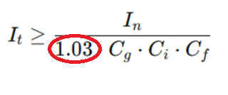
- Calculate C_{a} first;
- We know that the Ambient template is 25 degrees and the insulation is 70 degrees;
- Hence, in Table F1 on page 168 the answer is 1.03.

C_{g}=> grouping
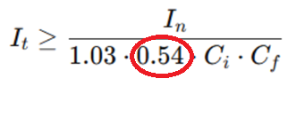
- We calculate Cg because of the Table F3 on page 170;
- The question states 6 cables already situated into the wall;
- Therefore this additional cable will make it seven.

C_{i} => thermal insulation
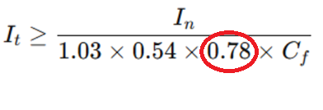
- C_{i} is deduced from Table F2 on page 169;
- C_{i} - factors in how insulation around a cable can affect its ability to dissipate heat and thus impact on the maximum amount of current that it can safely carry;
- The text informs us that the length of the insulation is 100mm this equates to 0.78.

C_{f} => account for 3036 fuse box
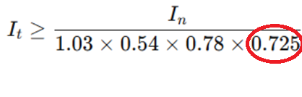
- C_{f} is deduced from page 167 at the bottom of the page;
- The answer is 0.725;
- This number is deduced from the text “a semi-enclosed fuse to BS 3036”.

I_{n} => represents the current at which the protective device is designed to operate in order to protect the circuit from damage

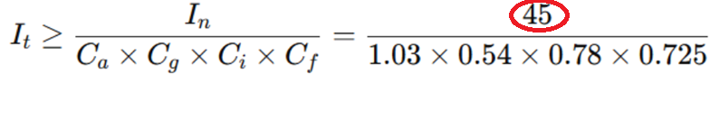
- I_{n} has been deduced from the second step to be 45 A;
- Because, we deduced the breaker size (I_{n}) based on the design current (I_{b});
- If the current exceeds 45 A then the breaker device will operate.

I_{t} = 143.1A

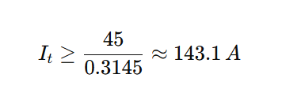

I_{Z} - Cable size. We need a cable size that can carry a 143.1 A current flow.
As mentioned in the question. We already have 6 circuits. With this addition, there will be 7 circuits.

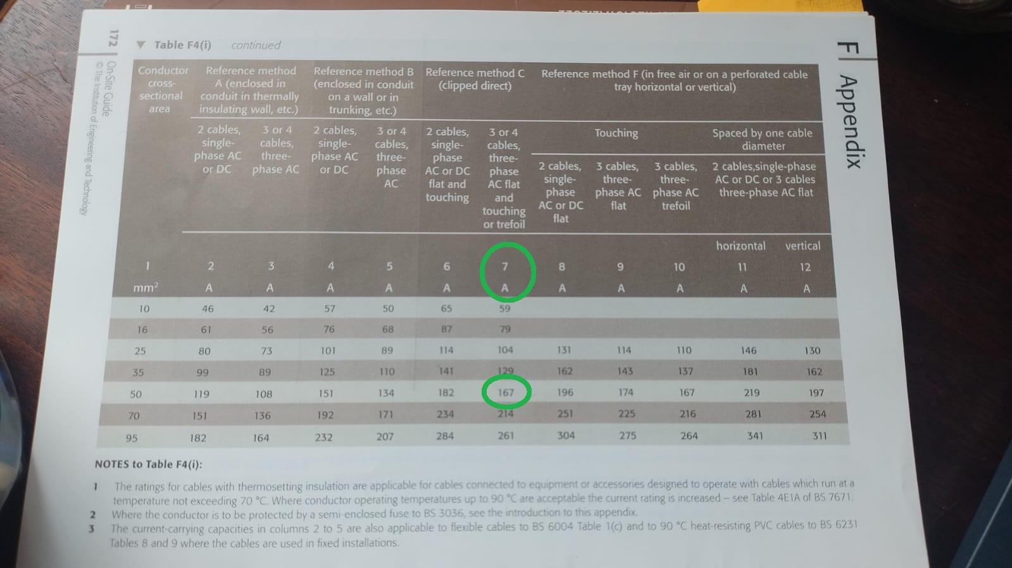

END SECOND PRACTISE

Voltage drop

Introduction

Z_{s} = Z_{e} + (R₁+R₂)
Z_{s} = Earth Fault Loop Impedance (EFLI)
Z_{e} = Connection from fuse box back to transformer
(R₁+R₂) = Line + CPC resistance. Internal from the circuit to the fuse box

R₁ = Live
R₂ = Earth
Z = Impedance

(R₁ + R₂)

Question

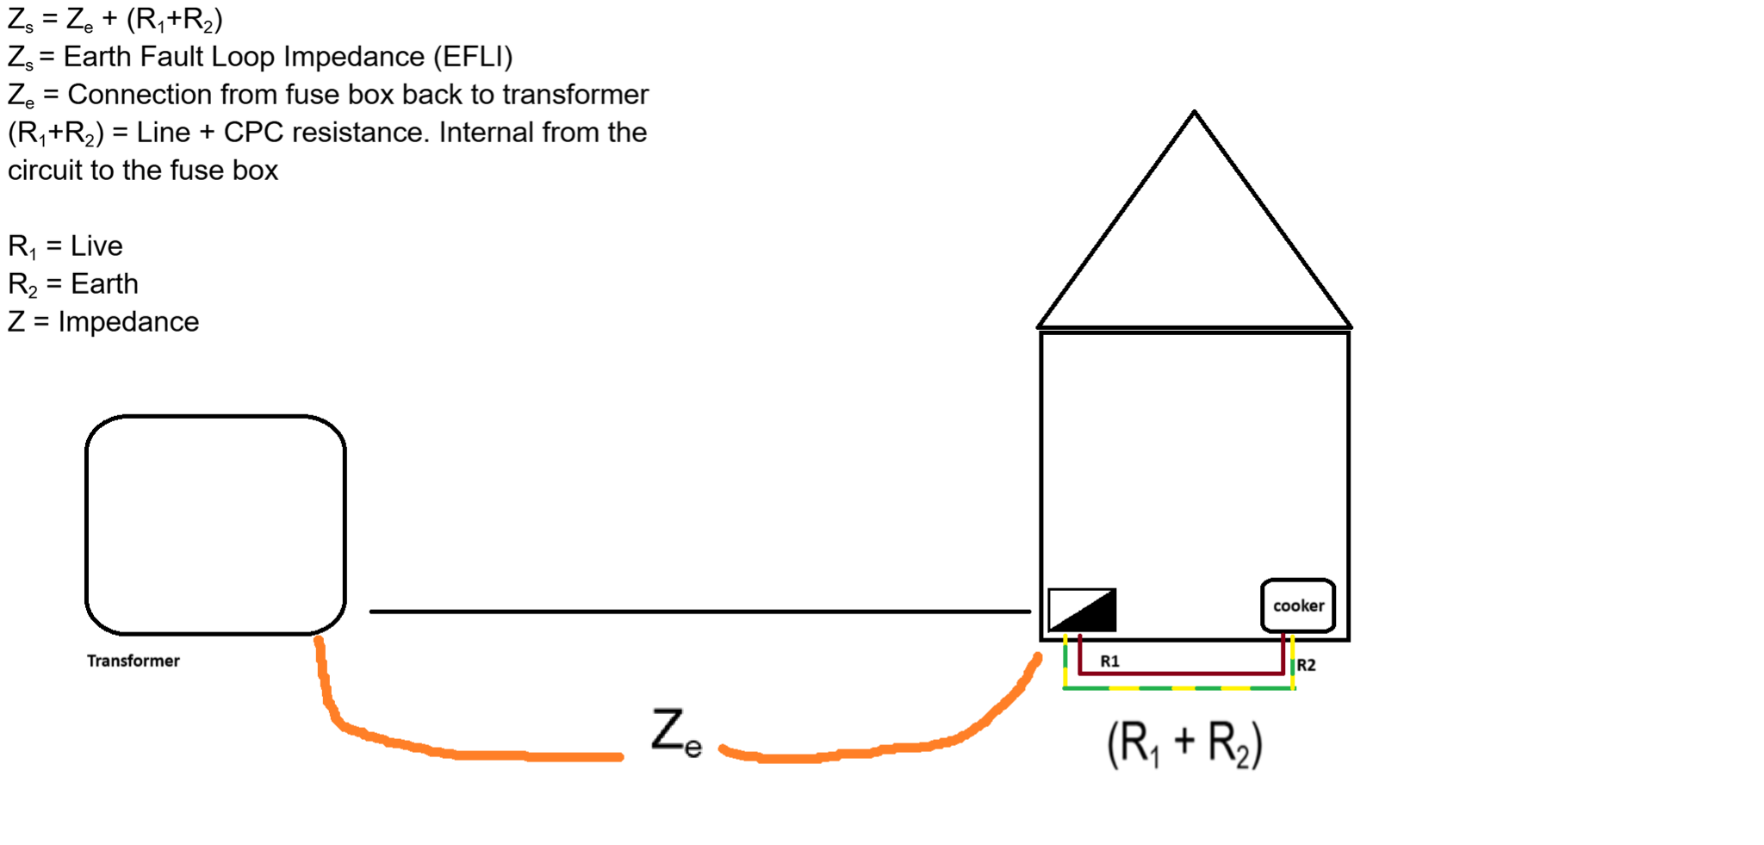

Working out

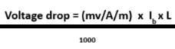

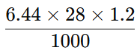

= 0.22 Ω

=> Z_{s} = Z_{e} + (R₁ + R₂)
=> 0.22 + 0.09
=> 0.31 Ω

230 / 0.31 = 741.94 A (will flow in an event of a fault)

